Introduction
Your Security Awareness Training Programme
Date [XX/XX/XX]

Overview
We’ve partnered with a leading human risk management company to help us make sure we keep our organisation, customers and colleagues safe against evolving cyber threats.
This ongoing training will involve you completing regular computer-based security awareness courses that are designed to improve our cyber security behaviour and help us reduce the likelihood of a data breach, without chipping away at our time or affecting our productivity.

Why is security awareness so important in today's world?
Any business or employee can be targeted
- Cyber criminals often target employees to gain access to sensitive information
- This is due to employees being seen as the 'weak link' in the cyber security chain
- Small to medium-sized businesses are just as likely to be hit by a cyber attack
- Criminals often launch widespread and untargeted attacks, meaning anyone is a target
Phishing attacks are getting harder to spot
- Phishing is where a cyber criminal attempts to trick victims into handing over sensitive information or installing malware, often by impersonating someone else via email
- 75% of businesses experienced phishing in 2020, and 22% of data breaches involve phishing
- Regular training ensures that we can keep up and combat new phishing techniques
We all make mistakes
- Over 90% of data breaches are a result of human error, like sending an email containing sensitive data to the wrong person, sharing passwords or leaving devices unattended
- Training helps us to make smarter security decisions every day and limit human error
Comply with regulations and frameworks
- Many regulatory frameworks and compliance standards list staff security awareness training as either mandatory or best practice whilst failure to act can result in fines

How will security awareness training benefit me?
- You'll help keep our employee and customer data safe
- You'll learn security skills that can also be applied at home
- You'll help the business avoid downtime or disruption

How will the training work?
- You'll be sent a short Gap Analysis Questionnaire to complete
This questionnaire measures your current security knowledge and identifies areas that need improvement, such as 'Secure Passwords' or 'Phishing'. This only takes between 10-15 minutes to complete and provides a baseline for what topics you'll be trained on first.
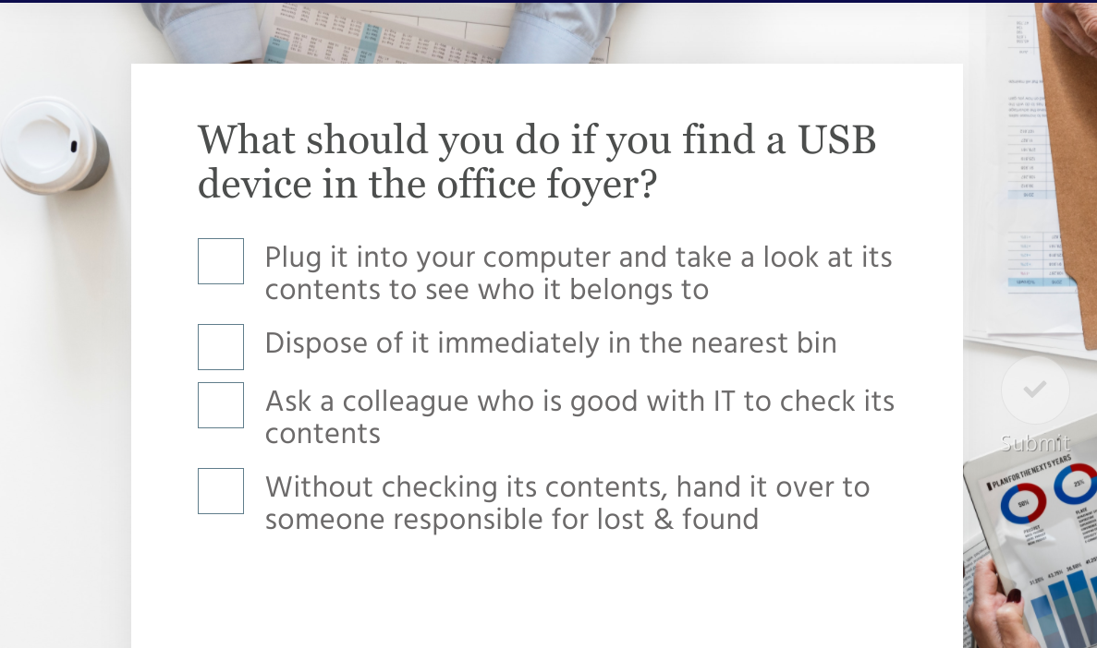
- Quick one-off questionnaire
- Measures your security knowledge
- Baselines your training journey

- You'll then be sent your first security awareness course
Once your Gap Analysis results are in, you’ll get an email invitation to access your first course. The course you receive first will depend on which area you scored lowest in during the Gap Analysis, e.g. 'Secure Passwords'. These courses take approximately 5-10 minutes to complete, which includes a quick quiz at the end that is used to measure how much you've learned.
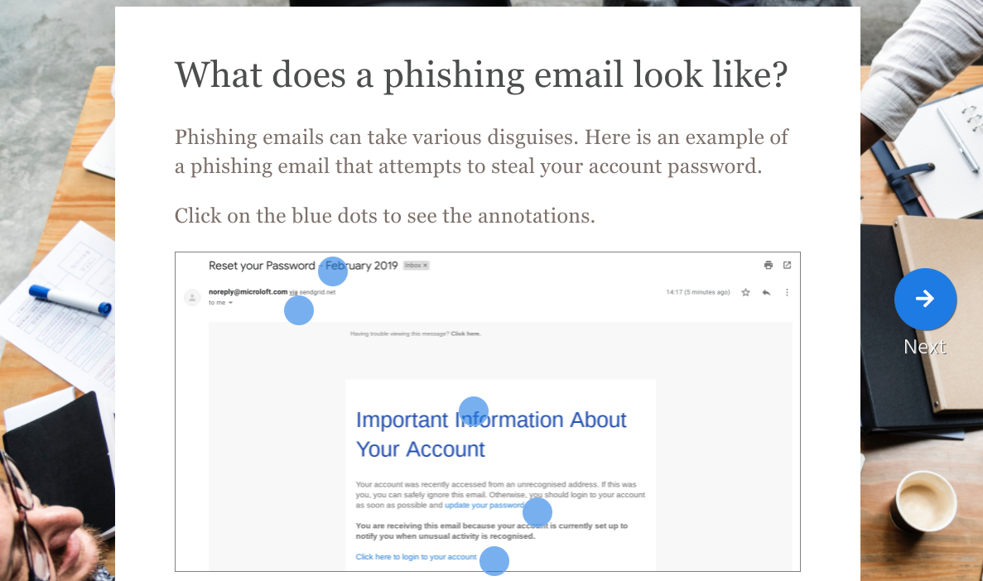
- Quick 5-10 minute course
- Short recap quiz at the end
- You'll be trained on weakest areas first

- You'll continue to receive regular course invitations over time
To help make sure your security behaviour is improving, you’ll receive an email invite to a new course at least once-per-month. You’ll be able to complete these courses when it is convenient for you, but we recommend completing these as soon as possible to avoid them building up and to ensure the training remains regular and effective.
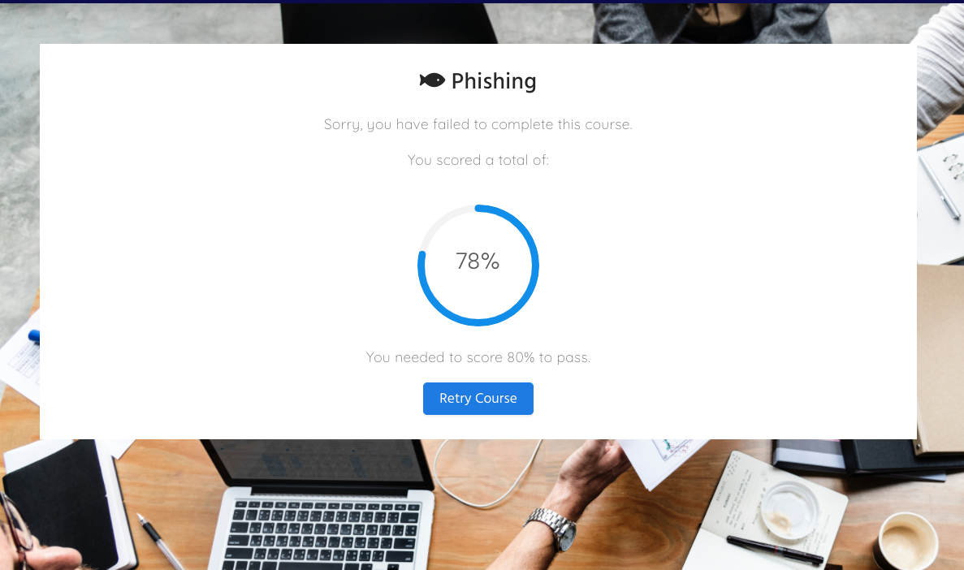
- You'll be invited to new courses over time
- Course grades and progress will be measured
- You'll see your grade at the end of each course

Frequently Asked Questions
How do I access my courses?
You'll receive an email invitation to your courses via your work email address. Each course is emailed out to you separately over time, where you'll find a link to begin your course.
Is course completion mandatory?
Yes, completing these courses is mandatory, as it helps us comply with various policies, regulations and frameworks, and helps protect our business from a potential data breach.
How long do these courses take to complete?
The one-off Gap Analysis Questionnaire that you'll receive at the start of your training journey takes approximately 10-15 minutes to complete, and each course takes approximately 5-10 minutes to complete.
What happens if I don't pass the quiz at the end of my course?
Each course requires you to get a minimum amount of questions correct in your quiz, with the minimum pass rate being 80% (unless set otherwise). If you score less than the minimum pass score, you'll simply be asked to re-start the course until you reach the set pass rate.
How often will I receive a course?
You'll receive a minimum of one course per month, but this frequency can be increased or decreased at the discretion of the training manager/admins.
Once I've received a course invite, how long do I have to complete it?
Once you've received your course invitation via email, you'll be able to complete the course at a time convenient for you. Although, it is expected that you complete these courses as soon as possible to keep your training regular, effective and to avoid courses building up.
What do the courses look like?
Your courses include a mixture of textual, video and interactive content to help keep them engaging, and unnecessary tech jargon has been avoided to make sure the courses are easy to understand.

Have another question?
If you have any questions please contact your IT, HR or Security team.

