Hello [first.name],

We have partnered with the security awareness training company usecure to roll out a new button for reporting phishing emails received at [company.name].
What is the button for?
As a user on [company.name]’s network, you are a potential target for cyber scams including phishing emails and ransomware. It is important that all attempts at phishing are reported appropriately and as soon as they are encountered, so that the IT team can protect [company.name]’s network, data and devices.
How do I use the Phish Alert Button?
The Phish Alert Button will be present in your Outlook mailbox on the web, desktop or on your mobile device. When you open an email you suspect is an attempt at phishing, you will simply need to click the Phish Alert Button and confirm that you wish to submit the email as a suspected phish.

Outlook Desktop
On Outlook Desktop, the Phish Alert Button will appear in the top ribbon.
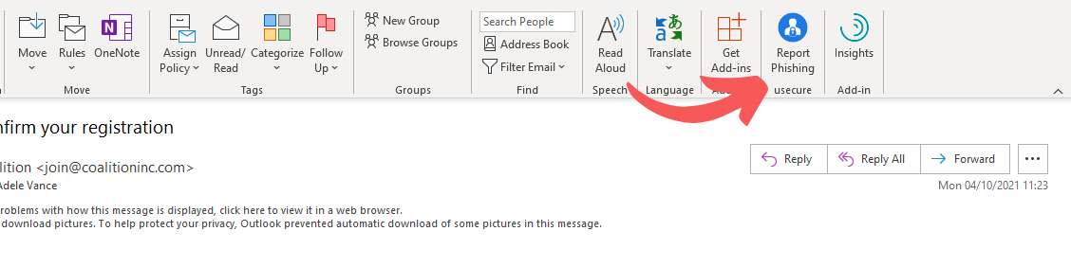
Outlook Web
On Outlook Web, the Phish Alert Button will appear in the top right when a message is open. If it is not visible, clicking the three dots in the top right will open a menu containing the button.
Android
Tap the three dots on the right above the body of the email. This will open a pull-up panel, where the icon for the Phish Alert Button will be at the bottom.
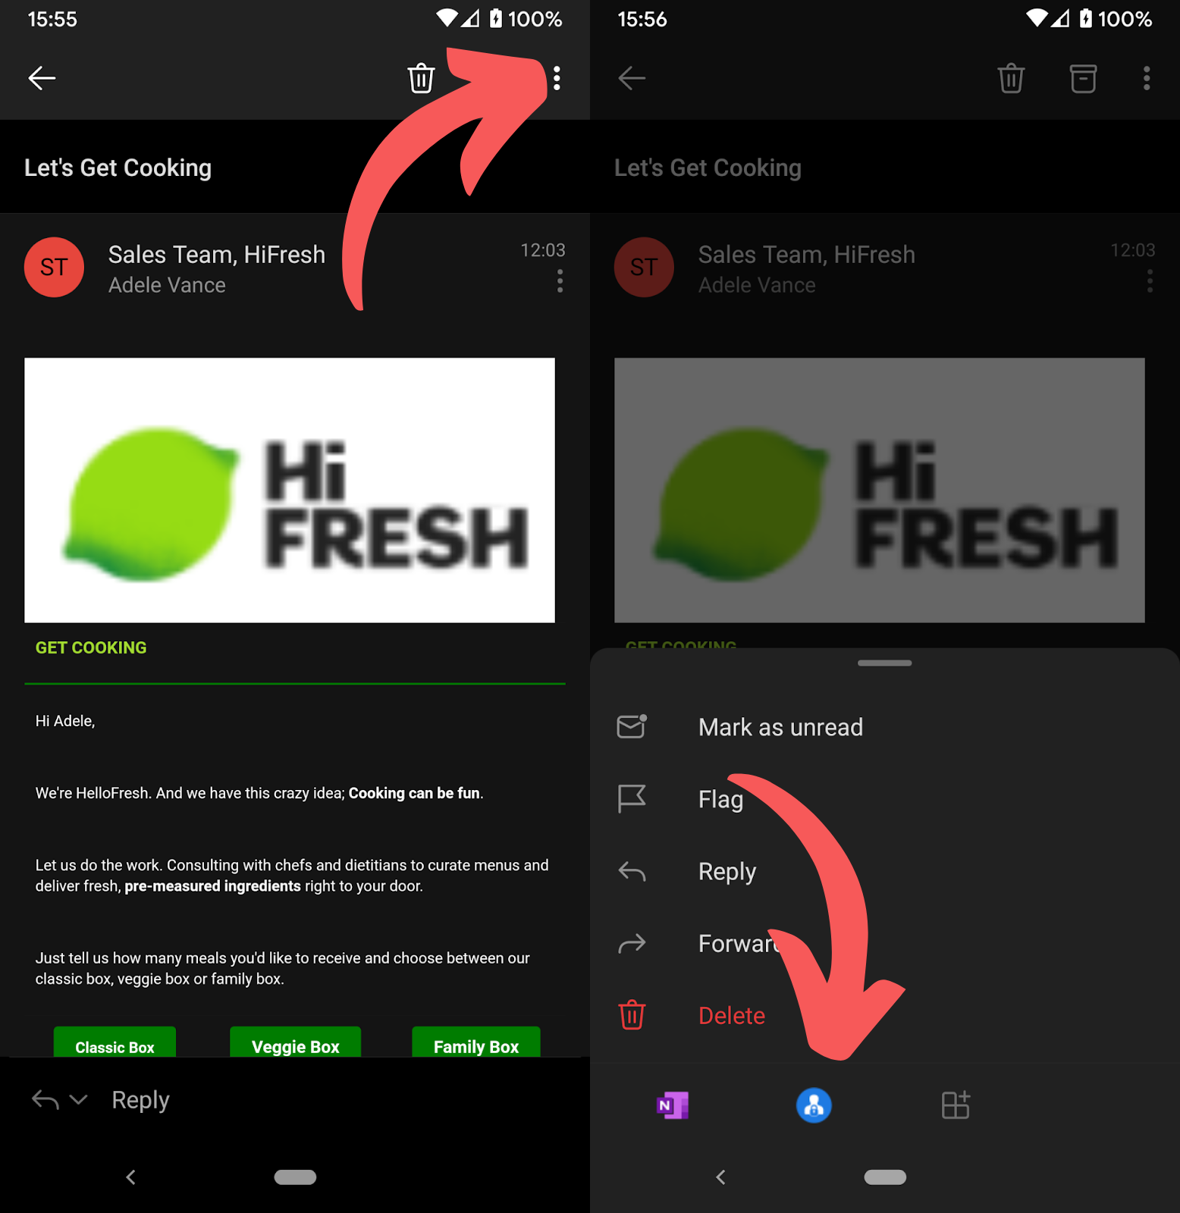

If you have any questions, feel free to contact [contact.email].

Thanks,
Your IT team

